**Abstract**

The roadmap for urban sustainability involves the transition to reliable and decarbonised energy networks. In this regard, business concepts based on sector coupling through the use of TES systems can play a key role. This research is placed in this context, with the aim of evaluating the flexibility potential of novel thermal energy storage systems in order to provide load shifting and peak shaving services to the electricity grid. The idea involves the modeling of the TES upscaling scenarios on the national territory and the simulation of energy demand starting from real data on the electricity grid from European TSOs. For this purpose, a 6-step methodology is used. In step 1, 15 min data on actual energy generation and energy consumption for Spain, Italy, Sweden, Germany and Austria from the ENTSOE Transparency Platform are acquired. The historical data series are analysed in a Python environment in order also to evaluate the RES surplus in each time-step (step 2). In step 3, the H&C energy demand of the building stock at national level is modelled, starting from the Demand.ninja approach. Step 4 concerns the modelling of the SoC of PCM and TCM systems on the basis of literature inputs and lab testing. Finally, the overall problem is optimized in Python environment, with the aim of minimizing the RES surplus thanks to the optimal integration of TES charging and discharging. As a result, alternative hourly load profiles based on load shifting and peak shaving are proposed, and the flexibility potential and sustainability impact of such systems is studied in detail. The research provides a contribution to the demonstration and optimization of sector coupling concepts. Lessons learned from this study can constitute insights for policy makers and technology providers, boosting research and diffusion of PCM systems and sorption technologies.

**Methodology Summary**

The research activity aims to evaluate the flexibility potential of novel TES systems in order to provide load shifting and peak shaving services to the electricity grid. The idea involves the modeling of the TES upscaling scenarios on the national territory and the simulation of energy demand starting from real data from EU TSOs. For this purpose, a 6-step methodology is used. In step 1, data time series on actual energy generation and energy consumption for Spain, Italy, Sweden, Germany and Austria from the entsoe Transparency Platform are analyzed and the RES surplus is evaluated in each time-step (step 2). In step 3, the H&C energy demand of the building stock is modeled, starting from the Demand.ninja approach. Step 4 concerns the modelling of the SoC of PCM and TCM systems on the basis of literature and lab testing. Finally, the overall problem is optimized in Python environment, with the aim of minimizing the RES surplus thanks to the optimal integration of TES charging and discharging. As a result, alternative hourly load profiles based on load shifting and peak shaving are proposed and the flexibility potential and sustainability impact of such systems is studied in detail.

**Flow chart**

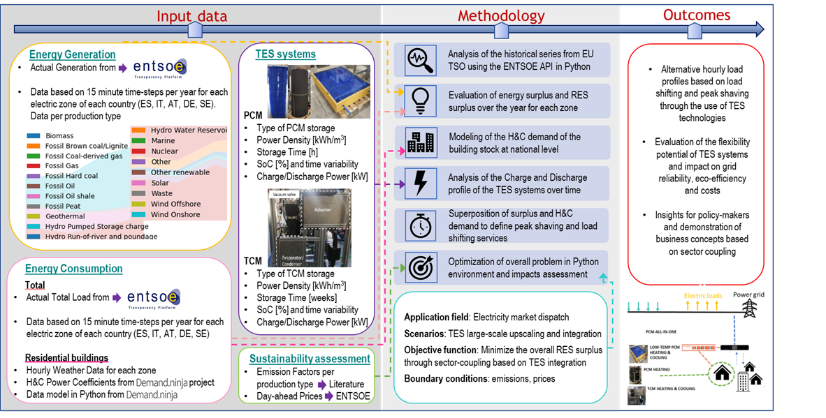

**Mathematical formulation**

**Historical time series scenario**

The total actual electricity generation from the zonal electricity mix, $G_{el}$, is calculated according to the following eq.

$$G_{el,i}=\sum_{j=1}^{n}{k_{i,j}= }k_{1}+k_{2}+⋯{+k}_{n}$$

With $k_{j}$ equal to the electricity generated [MWh] by the j-th production technology constituting the zonal electrical mix in each time step i, n equal to the total number of energy generation technologies constituting the zonal electrical mix in each time step, i.e. 1=geothermal plants, 2=oil generation systems etc. In this scenario $k_{j}$ is derived from the historical time series of data. the total actual energy consumption $D_{el}$:is also retrieved from the same source.

$$D_{el,i}=data_import[Actual Total Consumption]$$

Starting from $D_{el,i}$ and $G_{el,i}$, the surplus of electricity generated from renewable energy sources (RES) of the base case, ${Su}_{el,i}$, can be evaluated as the difference between energy generation and the energy provided by the storage systems of the zonal electricity mix, $S_{el}$, and the electricity demand of each zone.

$${Su}_{el,i}={\left.\sum_{j=1}^{n}{k_{i,j} }\right|}_{j=RES}+S_{el,i}-D_{el,i}$$

With:

$$S_{el,i}=S_{i,Hydro Water Reservoir}+S_{i,Hydro Pumped Storage}$$

As discussed in the methodology description section, the space heating and cooling demand of each national building stock, $D_{H\&C}$, is modelled starting from demand.ninja project in Python environment, as explained in detail in sub-section n.[] of the method section.

For the analysis of the flexibility potential of TES systems, the idea involves the modeling of the TES upscaling scenarios on the national territory and their charging/discharging according to the efrom the historical series from EU TSOs, therefore starting from the real data for generation and consuption. According to this perspective, the virtual contribution of the storage can be written as follows:

$$S_{el, i with TES}=S_{i,Hydro Water Reservoir}+S_{i,Hydro Pumped Storage}+S_{i,TES}$$

With:

$$S_{i,TES}={α_{1}∙x}_{i,TCM}+α_{2}∙x_{i,PCM}$$

Where $α_{1}$ and $α_{2}$ are the conversion factors from thermal energy to electrical energy respectively for the TCM and PCM storage and $x_{i}$ represents the thermal energy released from each type of storage during the discharge phase at the time i.

On the other hand, $y_{i}$ is the electrical energy stored inside the storage as an input at the time i during the charge phase. By combining this term with the overall energy consumption, a modified profile of the energy demand is obtained:

ALFA c= pd.readexcel()

$D_{mod,i}=D_{el,i}+y_{i,TCM}+y_{i,PCM}-{α_{C}∙x}_{i,TCM}-α_{C}∙x_{i,PCM, C}$**cooling**

$D_{mod,i}=D_{el,i}+y_{i,TCM}+y_{i,PCM}-{α_{H}∙x}_{i,TCM}-α_{H}∙x_{i,PCM,H}$**heatling**

The State of Charge (SoC) of the TCM storage can be formulated as follows:

${SoC}_{TCM,i}={SoC}_{TCM,0}+\sum_{i=0}^{i-1}{\frac{\left({COPhigh temperature heat pump ∙y}_{i,TCM}-x_{i,TCM}\right)}{C_{m,TCM}}∙η_{TCM,H} }$ HEATING demand

$${SoC}_{TCM,i}={SoC}_{TCM,0}+\sum_{i=0}^{i-1}{\frac{\left({COPhigh temperature heat pump ∙y}_{i,TCM}η_{TCM,charge}-x_{i,TCM}COPth,Hη_{TCM,charge}\right)}{C_{m}_TCM}∙ }$$

${SoC}_{TCM,i}={SoC}_{TCM,0}+\sum_{i=0}^{i-1}{\frac{\left({COPhigh temperature heat pump ∙y}_{i,TCM}-x_{i,TCM}\right)}{C_{m},TCM}∙η_{TCM,C} }$ COOLING demand

${SoC}_{TCM,i}={SoC}_{TCM,0}+\sum_{i=0}^{i-1}{\frac{\left({COPhigh temperature heat pump ∙y}_{i,TCM}η_{TCM,charge}-x_{i,TCM}COPth,C\right)}{C_{m}_TCM}∙ }$ as a function of the SoC at the initial time (${SoC}_{TCM,0}$), the maximum energy storage capacity of the system ($C_{m}$), the efficiency ($η_{TCM}$) and the energy flows during charge and discharge.

For the PCM storage the equation can be written as follows:

${SoC}_{PCM,i}={SoC}_{PCM,0}+\sum_{i=0}^{i-1}{\frac{\left({EERair-water∙y}_{i,PCM}η_{PCM,charge}-x_{i,PCM}η_{PCM,discharge}-y_{i},PCM*losses\right)}{C_{m}_PCM}∙ }$ COOLING

${SoC}_{PCM, T,i}={SoC}_{PCM,T,0}+\sum_{i=0}^{i-1}{\frac{\left({COPair-water∙y}_{i,PCM,H}-x_{i,PCM},H\right)}{C_{m},PCM}∙η_{PCM,H} }$ HEATING

cop=Heat/y

HEAT = y*cop

NOT 2 (PCM AND TCM) AGGREGATED VIRTUAL STORAGE BUT 3 (PCM,C PCM,H AND TCM)

The Objective Function (OF) is the overall renewable surplus evaluated in the flexibility scenario with TES systems. OF has to be minimized and can be expressed as follows:

$$OF=\sum_{i=0}^{i=T}{\left[{-D}_{el,i}+\sum_{j=1}^{n}{k_{i,j}+S_{el,i}+}\left(α_{1}x_{i,TCM}-y_{i,TCM}\right)+\left(α_{2}x_{i,PCM}-y_{i,PCM}\right)\right] }$$

**Constraints:**

As charging and discharging cannot occur simultaneously the following constraints are valid:

$$\left\{\begin{aligned}if x_{i,TCM}>0 → y_{i,TCM}=0 \\ if y_{i,TCM}>0 → x_{i,TCM}=0\end{aligned}\right.$$

$$\left\{\begin{aligned}if x_{i,PCM}>0 → y_{i,PCM}=0 \\ if y_{i,PCM}>0 → x_{i,PCM}=0\end{aligned}\right.$$

Due to the use of both PCM and TCM storage an additional constraint is included in the optimization problem:

DH

DC

**Upper Bounds (UB) and Lower Bounds (LB): $LB≤X≤UB$**

$$o≤x_{i,TCM}≤{\frac{1}{α_{1}}D}_{H\&C,i}$$

$$o≤y_{i,TCM}≤{Su}_{el,i}$$

$$o≤x_{i,PCM}≤{\frac{1}{α_{2}}D}_{H\&C,i}$$

$$o≤y_{i,PCM}≤{Su}_{el,i}$$

$$x\%≤{SoC}_{i,PCM}≤X\%$$

$$x\%≤{SoC}_{i,TCM}≤X\%$$

**Sustainability impact**

The equivalent CO2 intensity of the electricity imported from the grid, ICO2 is calculated for each time-step of the year using the specific conversion factors cj derived from the literature [ref].

$$I_{CO2,i}=\sum_{j=1}^{n}{k_{i,j}∙ c_{j}}$$

For the economic evaluation, the historical hourly data of the electricity price Pj disclosed by the electricity market operators (EU ENTSOE) are used.

**Achievements:**

* Implementation of the (draft) optimization model in Python environment

**Next steps:**

* Refine the model with additional computational details and constraints:
  + Constraint on the PCM according to which charge can occur if discharging is expected in for example the following 12 hours (Predictive)
  + Integration of the national H&C Demand model
  + Collaboration in the development of conversion coefficients
  + Identification of zonal-national storage capacities
  + Scenarios with further objective functions, quantifications of environmental benefits and costs